**Experiment 8**

**Aim:** Implementing master/Slave architecture in Jenkins.

**Procedure:**

**Step 1:** Go to manage Jenkins then go to manage node and clouds.



Here configure a new node and configure it in the following way:

‘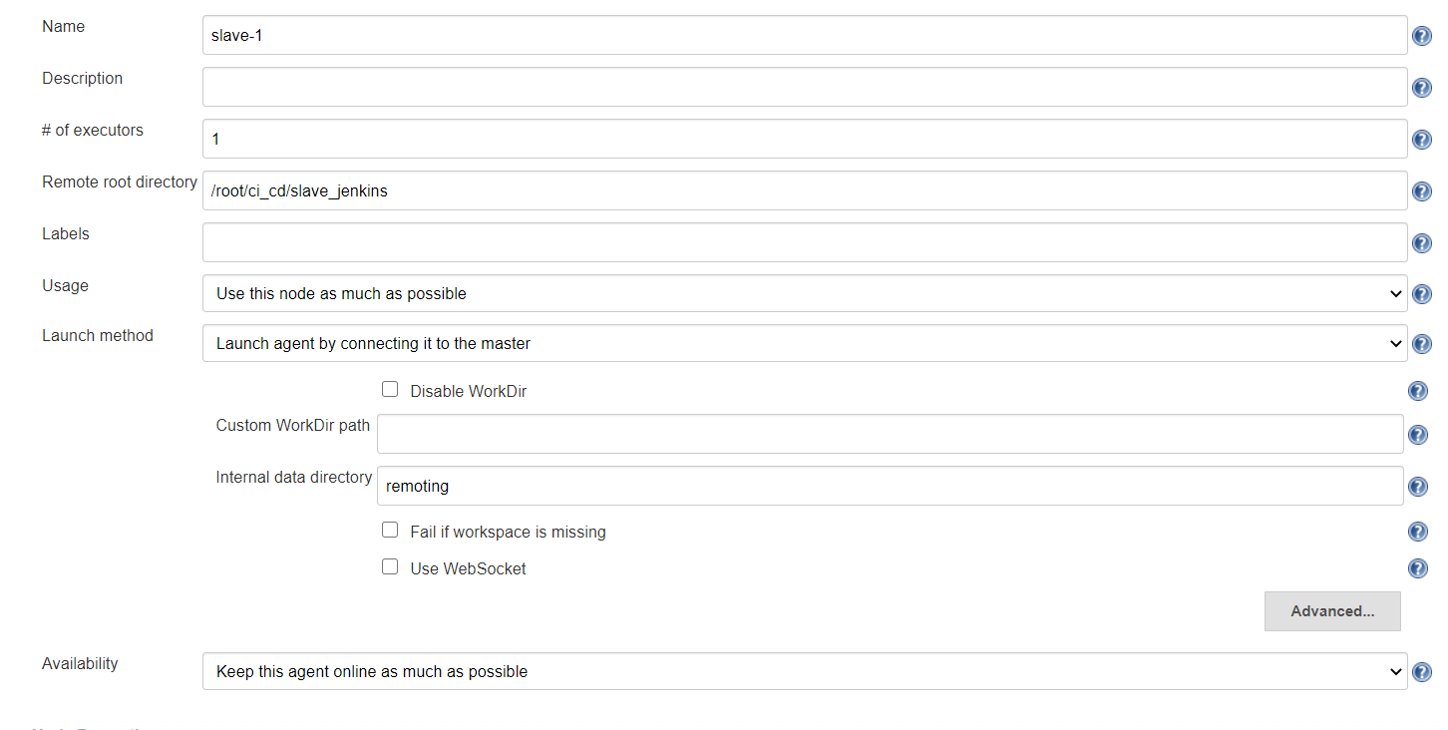

**Step 2:** Start the node by the command given:

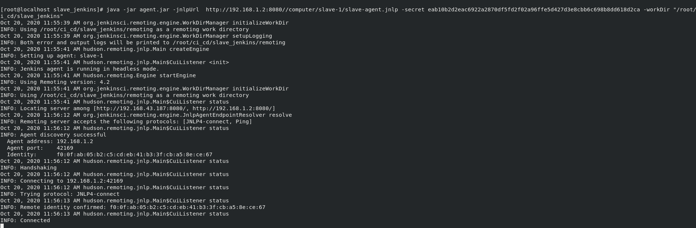

After the node has been configured you will see the following on the bottom left of the screen

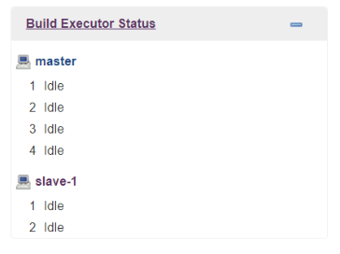

**Step 2:** Now configure a Jenkins job to run on the node configured. Configure the job in the following way.

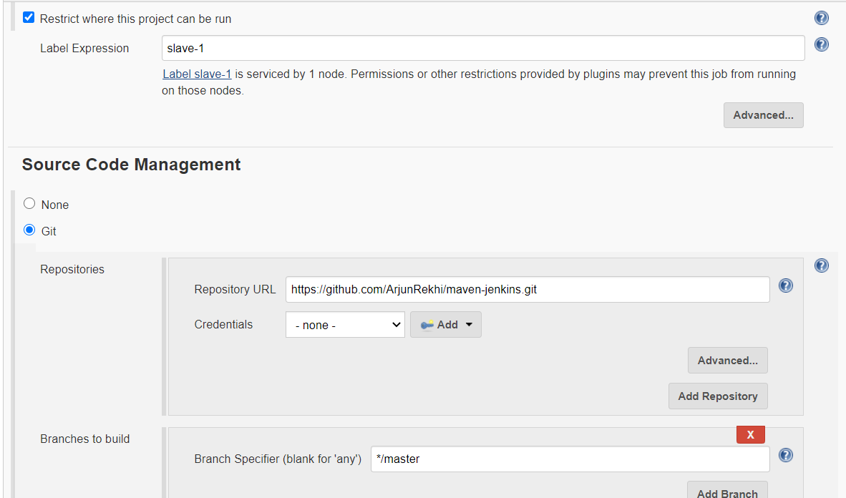

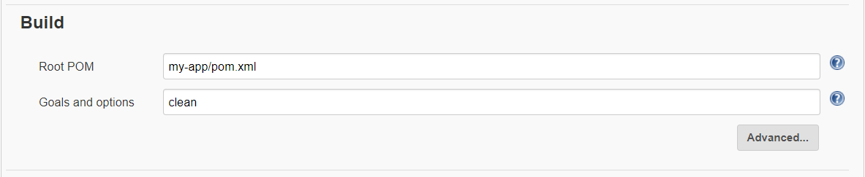

**Step 3:** Click on build now to start the running of the project.

You will be able to see that the project starts running inside the node configured:

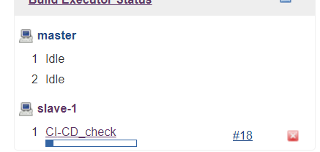

The output as seen in console output:

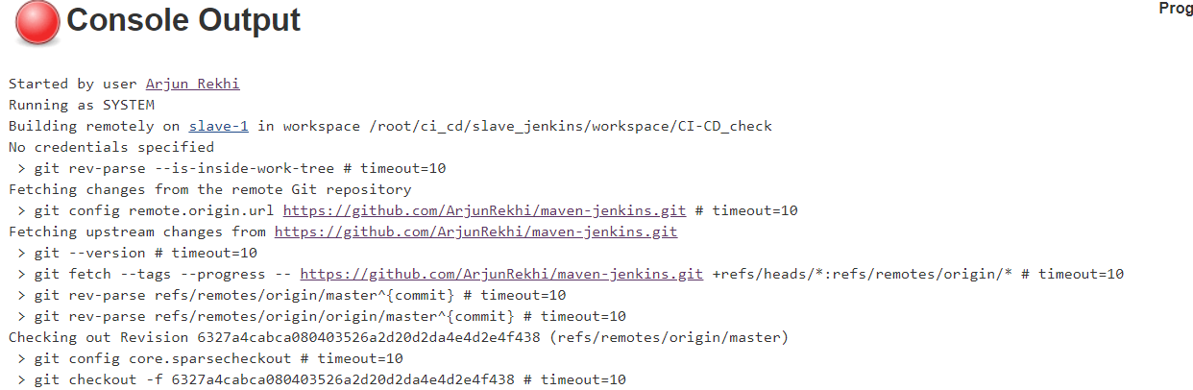

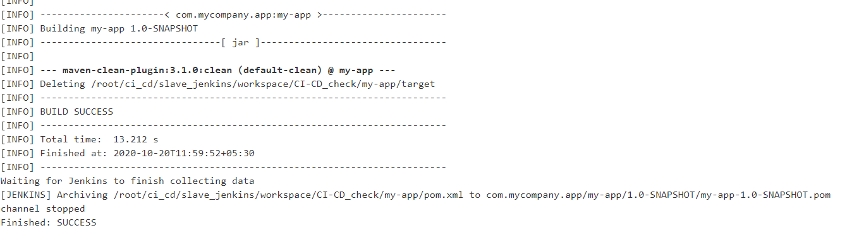

Submitted by:

Arjun Rekhi

500068109

R171218028